Technical Documentation — MaStR Export → Snowflake Ingestion + CRM Matching
This document explains what was built, why, and how—
If you need more details on the MaStR variables, you can find them in Master data variable.docx.
1) Executive Summary (What problem this solves)
We need to determine, for each customer record in CRM (Salesforce export table), whether their metering location code (MeLo / METERINGCODE) is:
- present in the German MaStR dataset, and
- properly mapped to:
  - a SEL (Lokation / location number) and
  - a SAN (grid connection point number), and
- has at least one registered unit at that SEL:
  - PV (solar) unit and/or
  - battery storage unit.
To do this reliably on a scale, we implemented a pipeline that:
- downloads the MaStR “Gesamtdatenexport” ZIP,
- extracts only required XML files,
- parses XML in a streaming way,
- loads data into Snowflake staging tables,
- merges into persistent “current” tables,
- builds a summary table per MeLo,
- creates a view that classifies each CRM row with a MATCH_STATUS.
The table we will use:
"STG_NETZANSCHLUSSPUNKTE"
"STG_LOKATIONEN"
"STG_EINHEITEN_SOLAR"
"STG_EINHEITEN_STROMSPEICHER"
"CUR_NETZANSCHLUSSPUNKTE"
"CUR_LOKATIONEN"
"CUR_EINHEITEN_SOLAR"
"CUR_EINHEITEN_STROMSPEICHER"
"MASTR_MELO_SUMMARY"
"VW_CUSTOMER_MASTR_MATCH"

***What someone needs before running update.py
1) Python environment (recommended)
- Create and use a Python virtual environment so dependencies are isolated from the system Python.
- Install the required packages (e.g., pandas, requests, snowflake-connector-python, cryptography, tqdm).
2) Project location / working directory
- Run the script from the project checkout (or at least ensure you have access to the folder that contains update.py).
- By default, the script uses the folder containing update.py as its base directory (for cache/log files and for resolving the .env path).
3) Snowflake configuration via .env (required unless you set environment variables another way)
- Before running, create a .env file in the same folder as update.py (or provide a custom path via --env-file).
- The .env file must contain the Snowflake connection settings used by the script, e.g.:
SNOWFLAKE_ACCOUNT=...
SNOWFLAKE_USER=...
SNOWFLAKE_ROLE=...
SNOWFLAKE_WAREHOUSE=...
SNOWFLAKE_DATABASE=...
SNOWFLAKE_SCHEMA=...

2) High-level Architecture
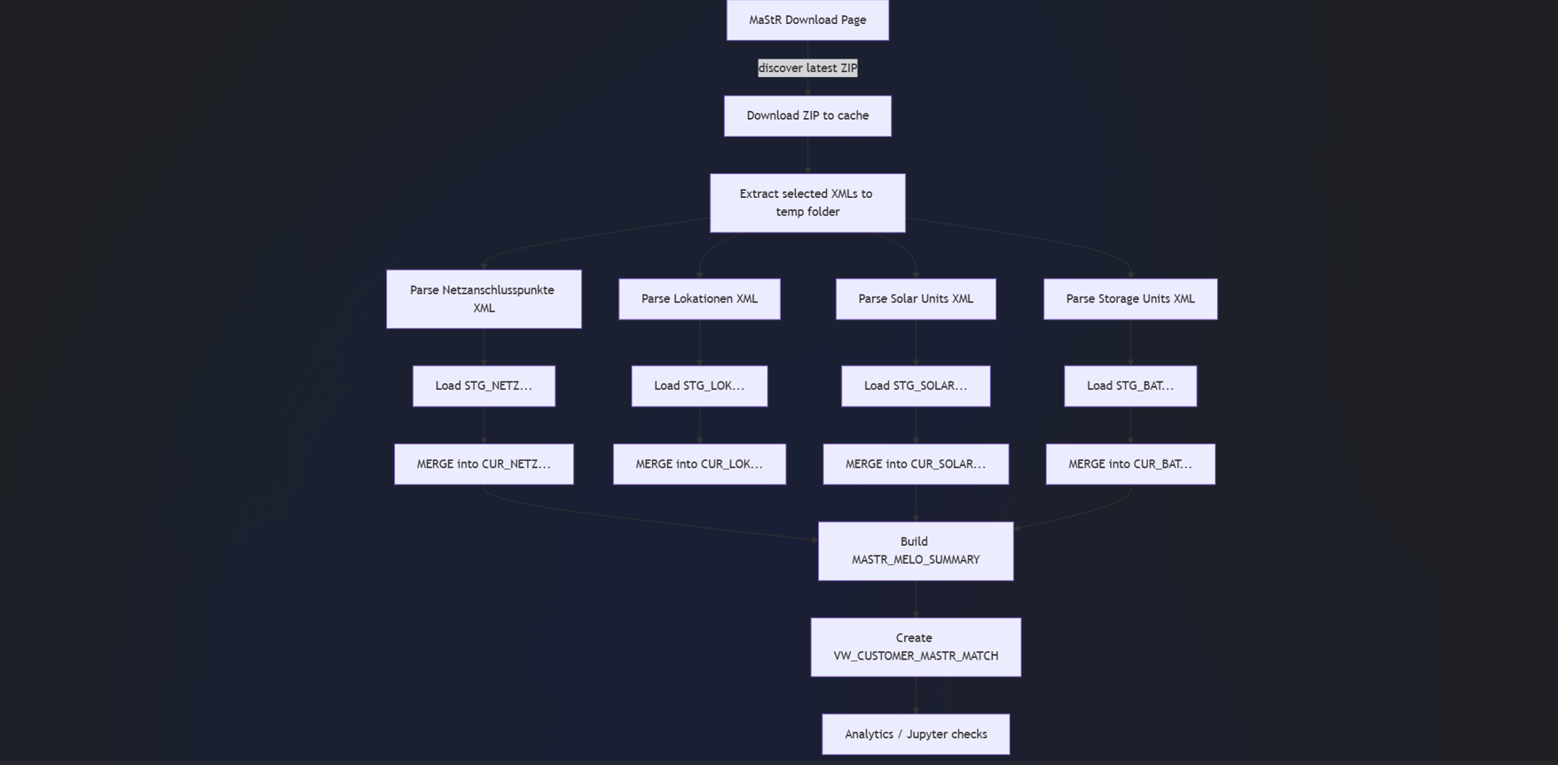
3) Data Inputs and What We Use From XML
3.1 MaStR datasets used
From the MaStR export ZIP we extracted and processed only these XML families:
Table:
1) Netzanschlusspunkte
2) Lokationen
3) EinheitenSolar
4) EinheitenStromSpeicher
3.2 XML elements (tags) extracted per dataset
XML schemas can have slightly different tag spellings; the code therefore “tries” multiple alternatives via a helper (pick()).
A) Netzanschlusspunkte (mapping layer)
We read these tags (examples; code supports variants):
- NetzanschlusspunktMastrNummer / NetzanschlusspunktMaStRNummer → SAN
- LokationMaStRNummer / LokationMastrNummer → SEL
- Messlokation / MELO / MeteringCode → MELO
Why this matters: This dataset is the bridge that connects MeLo to a Lokation (SEL) and grid connection point (SAN).
B) Solar units
We read:
- unit ID: EinheitMastrNummer / EinheitMaStRNummer
- SEL: LokationMaStRNummer / LokationMastrNummer
- address-like fields: Postleitzahl, Ort
- dates: Registrierungsdatum, Inbetriebnahmedatum
- power: Bruttoleistung, Nettonennleistung, ZugeordneteWirkleistungWechselrichter
- some descriptive fields: NameStromerzeugungseinheit
- plus a few flags like SpeicherAmGleichenOrt (kept as raw text)
C) Storage units
Same concept as solar: unit ID + SEL + power/dates, plus storage-specific fields like:
- EEGMastrNummer (if present)
4) How the Code Works (Step-by-step)
All logic is implemented in a single Python script: update.py.
4.1 Snowflake connection (how code connects to Snowflake)
Configuration is via environment variables (optionally loaded from a .env file):
- SNOWFLAKE_ACCOUNT
- SNOWFLAKE_USER
- SNOWFLAKE_ROLE
- SNOWFLAKE_WAREHOUSE
- SNOWFLAKE_DATABASE
- SNOWFLAKE_SCHEMA
Auth modes supported:
- externalbrowser (SSO in browser)
- jwt (service auth using private key)
What this means:
- The script runs inside your Snowflake role and schema context.
- All tables/views are created in SNOWFLAKE_DATABASE.SNOWFLAKE_SCHEMA.
4.2 Download: finding the latest MaStR ZIP and caching it
Goal: Avoid re-downloading a huge file every time but still be able to force a refresh.
Key behaviors:
- If a cached ZIP exists and is a valid ZIP → reuse it.
- Otherwise download it.
- Optionally prune old cached ZIPs.
Why the export date matters:
The MaStR download URLs typically contain a date (e.g., Gesamtdatenexport_20250101_...zip). We use that as a stable cache key.

4.3 Extraction: only extracting relevant XML files to a temp directory
The ZIP contains many XML files; we only extract filenames that start with:
- Netzanschlusspunkte_
- Lokationen_
- EinheitenSolar_
- EinheitenStromSpeicher_
Extraction target: a run-specific temp folder like: cache/run/tmp_extract_<run_id>/...
Cleanup:
After success, the temp extraction folder is deleted (with retries—important on Windows).
4.4 Parsing: streaming XML parsing (memory-safe)
The MaStR XML files are large. We therefore parse using xml.etree.ElementTree.iterparse which reads incrementally and clears elements after processing.
Key features:
- We infer the XML “record tag” automatically (the element name for each record).
- We parse one record at a time, map it to a dictionary, then batch-load.
Performance note:
We also specify wanted_tags so we don’t store irrelevant XML fields.

5) How XML becomes Snowflake tables
5.1 Two-layer table design: STG_ and CUR_
We use a standard ingestion pattern:
- STG_ (staging)* tables: truncated and fully reloaded each run
- CUR_ (current)* tables: persistent tables updated via MERGE (upsert)
This makes runs repeatable and helps avoid partial updates.

5.2 Table creation / schema evolution
The code ensures required tables exist and adds missing columns if needed.
Relevant code excerpt (concept):
pythonCopy
def ensure_table_with_columns(conn, db, schema, table, columns):
run_sql(conn, f"CREATE TABLE IF NOT EXISTS db.schema.table (...)")
existing = get_existing_columns(...)
for col in columns:
if col not in existing:
run_sql(conn, f"ALTER TABLE ... ADD COLUMN ...")
Outcome:
You can deploy improvements to columns without manually altering Snowflake tables.
5.3 MERGE STG → CUR (update-on-change)
STG contains the newly loaded data. Then we MERGE it into CUR:
- Insert records that are new (key not in CUR)
- Update records only if something changed (checked via RECORD_HASH)
- Otherwise, do nothing
STG is reloaded each run (truncated → loaded from the current XML), then merged into CUR.
Why RECORD_HASH exists:
Instead of comparing every column, we store a hash of relevant values. This makes change detection simple and fast.
6) Summary Build: MASTR_MELO_SUMMARY
6.1 Why we need a summary table
Raw CUR tables are too granular (multiple SAN/SEL per MELO, many units per SEL). For matching CRM customers efficiently we build a MeLo-centric summary:
For each MELO:
- representative SEL and SAN
- list of all SEL/SAN observed
- number of solar units, total PV power
- number of storage units, total storage power
- lists of unit IDs (for debugging)
6.2 How it is built (conceptually)
- Extract (MELO, SEL, SAN) mapping from CUR_NETZANSCHLUSSPUNKTE
- Join solar units on solar.LOKATION_MASTR_NUMMER = SEL
- Join storage units on storage.LOKATION_MASTR_NUMMER = SEL
- Aggregate counts and sums per MELO
- Write into CREATE OR REPLACE TABLE MASTR_MELO_SUMMARY
Result: a single table that makes CRM matching fast and explainable.

7) Customer Matching View: VW_CUSTOMER_MASTR_MATCH
7.1 Purpose
Provide a row-per-CRM-record view that includes:
- CRM identifiers
- MELO + MaStR mapping fields (SEL/SAN)
- unit counts (solar/storage)
- final MATCH_STATUS
7.2 Business logic: statuses
Table
Status | Meaning
CUSTOMER_NO_MELO | CRM row has no METERINGCODE
NO_MATCH | CRM MeLo not found in MaStR mapping (netz dataset)
INCOMPLETE_MASTR_MAPPING | MeLo exists but SEL or SAN missing
MISSING_UNITS | MeLo+SEL+SAN exist but no solar/storage units at SEL
MATCH | MeLo exists + SEL + SAN + at least one unit

8) Running the Pipeline (Operational Usage)
8.1 Full run (download → extract → parse/load → merge → summary/views)
bashCopy
python update.py
8.2 Summary-only run (no download/extract/load; rebuilds summary + views from existing CUR tables)
bashCopy
python update.py --summary-only
8.3 Download-only run
bashCopy
python update.py --download-only
8.4 Where logs and run metadata go
- Logs: cache/run/update_<export_date>.log
- Run metadata: cache/run/last_run_meta.json

9) Validation We Performed (Proving it works)
We created a compact KPI check in Jupyter that confirms:
- Actual matches are never more than theoretically possible
- The gap is fully explained by MISSING_UNITS and INCOMPLETE_MASTR_MAPPING
Your results:
- CRM total: 99,038
- Theoretically matchable (MeLo present in MaStR): 43,190
- Matched: 43,157
- Gap: 33
- Explanation:
  - MISSING_UNITS: 33
  - INCOMPLETE_MASTR_MAPPING: 0
Interpretation:
All mapping cases are structurally complete (SEL+SAN exist when MeLo exists). The only unmatched-but-present cases are those where no PV/storage unit is registered at the mapped SEL.
10) How to Investigate the 33 MISSING_UNITS Cases
A MISSING_UNITS case means:
- MeLo exists in MaStR
- SEL + SAN exist
- but no solar or storage units found at that SEL
A minimal Jupyter query to list them:
pythonCopy
import pandas as pd

q = """
SELECT
"Salesforce Customer ID" AS CUSTOMER_ID,
METERINGCODE AS MELO,
SEL, SAN,
SOLAR_UNITS, STORAGE_UNITS
FROM MSB_SANDBOX.SANDBOX_TASNIA_SANTA.VW_CUSTOMER_MASTR_MATCH
WHERE MATCH_STATUS = 'MISSING_UNITS'
ORDER BY MELO;
"""
df_missing = pd.read_sql(q, conn)
df_missing

11) Notes on Finding the View in Snowflake UI (Common confusion)
All objects are created in the schema configured by:
- SNOWFLAKE_DATABASE
- SNOWFLAKE_SCHEMA
So in the Snowflake UI, make sure you are browsing:
- Database:MSB_SANDBOX
- Schema:SANDBOX_TASNIA_SANTA
- View: VW_CUSTOMER_MASTR_MATCH
To verify existence:
sqlCopy
SHOW VIEWS LIKE 'VW_CUSTOMER_MASTR_MATCH' IN SCHEMA MSB_SANDBOX.SANDBOX_TASNIA_SANTA;
12) What We Delivered (Final State)
After implementing and running update.py, we have:
- Automated ingestion of MaStR export datasets into Snowflake (STG_* → CUR_*)
- A stable summary table MASTR_MELO_SUMMARY (MeLo-centric, aggregation + debugging lists)
- A customer-level match view VW_CUSTOMER_MASTR_MATCH with clear statuses
- Verified outcomes that behave exactly as expected (theory vs. actual matches reconciles cleanly)

